**RETRO 2014 Developper’s Guide**

* Development Tools
* Architecture
* Clustering method & Descriptor

Mai 25, 2014

__________________________________________________________________

**How to Contact Us:**

Jean-Yves RAMEL ([ramel@univ-tours.fr](mailto:ramel@univ-tours.fr))

Frédéric RAYAR ([rayar@univ-tours.fr](mailto:rayar@univ-tours.fr))

Laboratoire d'Informatique

Equipe Reconnaissance des formes et analyse d'images

64, avenue Jean Portalis

37200 – Tours

France

For more contact information, please refer to the PaRADIIT project website <https://sites.google.com/site/paradiitproject/>

**Licence**

RETRO 2012

Copyright © RFAI, LI Tours, 2011-2012

This program is free software: you can redistribute it and/or modify it under the terms of the GNU Lesser General Public License as published by the Free Software Foundation, either version 3 of the License.

This program is distributed in the hope that it will be useful, but WITHOUT ANY WARRANTY; without even the implied warranty of MERCHANTABILITY or FITNESS FOR A PARTICULAR PURPOSE. See the GNU Lesser General Public License for more details.

# You should have received a copy of the GNU Lesser General Public License along with this program. If not, see <http://www.gnu.org/licenses/>.

**Partners**

The authors would like to thank all the members of the BVH-CESR for their collaboration. This work has been supported by the Google Digital Humanities research Awards given to the Computer Science Laboratory of Tours (RFAI team).

|  |  |
| --- | --- |
|  | <http://international.univ-tours.fr/> |
|  | <http://polytech.univ-tours.fr/> |
|  | <http://www.li.univ-tours.fr/> |
|  | <http://www.rfai.li.univ-tours.fr/> |
|  | <http://www.google.fr/intl/en/about/> |
|  | <http://cesr.univ-tours.fr/> |
|  | <http://www.bvh.univ-tours.fr/> |

### Content

Content 5

PART I - DEVELOPMENT TOOLS 7

Development constraints 8

PART II - SOLUTION ARCHITECTURE 9

Projects 10

Package diagram 11

PART III - CLUSTERING METHODS & DESCRIPTORS 12

Plugins already implemented 13

Develop a clustering method 14

Develop a descriptor 14

Develop a document reader 14

Add a clustering method 15

Add a descriptor 15

## PART I

## DEVELOPMENT TOOLS

### Development constraints

* **IDE** : Visual Studio 2012
* **Language** : C# with .NET 4.5 Framework

If the developer wants to modify the RETRO source code he has to develop in **C#** and use at least the **4.5 version of .NET** framework and the **2012 version of Visual Studio**.

In addition, RETRO has been developed according the **MVVM** (Model – View – ViewModel) design pattern. So it’s important the developer respect this model in developing RETRO.

## PART II

## SOLUTION ARCHITECTURE

### Projects

The RETRO solution comprised 4 projects :

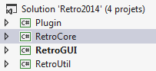

|  |  |
| --- | --- |
| 1. **Plugin** | This project contains the database object model. It contains the tools to read and use a clustering method (except the Template Matching method which is defined in the **Clustering** project), a descriptor or a document reader plugin. Normally, the developer don’t have to modify it. |
| 1. **RetroCore** | This project is the principal project of the solution. It permit also to define a RETRO model project and the returned values. It contains the clusters and shapes characteristics and all the Template matching clustering method features. |
| 1. **RetroGUI** | This project contains the principals’ views of the project and the principal methods too. |
| 1. **RetroUtil** | This project contains various small tools, like dynamic splash for example. |

### Package diagram

Here is the package diagram of RETRO:

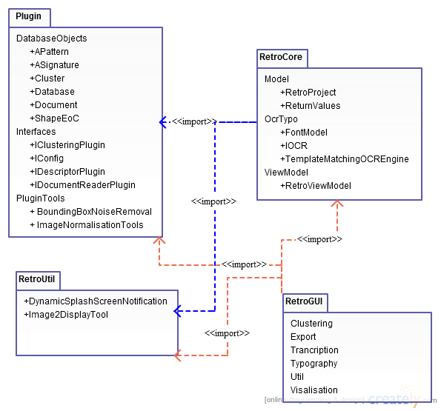

## PART III

## CLUSTERING METHODS & DESCRIPTORS

### Plugins already implemented

RETRO contains already many clustering methods and descriptors in order to realize a clustering.

The plugins already implemented are in the directory:

*ExternalLib\DLLs_MethodesClustering_Descripteurs*

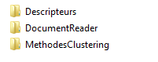

Each directory contains respectively:

* **Descriptors**: DirectionalDescriptorPlugin and ZernikeDescriptorPlugin
* **Document Reader**: AltoReaderPlugin
* **Clustering methods**: BIRCHClusteringPlugin and KMedoidClusteringPlugin plugins.

### Develop a clustering method

If the developer wants to develop a new clustering method, he has to develop it according the *ICLusteringPlugin* Interface in the project **Plugin**.

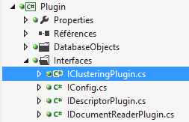

This interface contains all the method prototypes that the developer has to develop to create a new clustering method.

### Develop a descriptor

To develop a descriptor, the developer has to do the same thing that for a clustering method, except he has to follow the *IDescriptorPlugin* Interface to develop his own descriptor.

### Develop a document reader

Actually RETRO permit to read only one type of files to realize the clustering: File ALTO + Pictures and a document reader for this file is already implemented.

However, if the developer wants to develop his own reader document, he had to consult the *IDocumentReader* Interface.

### Add a clustering method

If the developer want to add his clustering method (which he has developed like it is explained in the “Develop a clustering method” part) he has to follow 2 steps:

1. Add his plugin (*.dll) in the right directory:

*ExternalLib\DLLs_MethodesClustering_Descripteurs\MethodClustering*

1. Complete the Xml file ***ClusteringMethods*** presents in the ***XML_Files*** director according the given model :

**<Method>**

**<Name>**Name of the clustering method to add**</Name>**

**<Description>**Write here the description of the clustering method to add.

**</Description>**

**<Path>**

..\\..\\..\\ExternalLib\\DLLs_MethodesClustering_Descripteur s\\MethodesClustering\\PluginOfTheClusteringMethodToAdd.dll

**</Path>**

**</Method>**

Then, the clustering method will be automatically added to RETRO and will be available for the user to realize a clustering.

### Add a descriptor

If the developer want to add his clustering method (which he has developed like it’s explain in the “Develop a clustering method” part) he has to follow 2 steps:

1. Add his plugin (*.dll) in the right directory:

*ExternalLib\DLLs_MethodesClustering_Descripteurs\Descripteurs*

1. Complete the Xml file ***Descriptors*** presents in the ***XML_Files*** director according the given model :

**<Descriptor>**

**<Name>**Name of the descriptor to add**</Name>**

**<Description>**Write here the description of the descriptor to add.

**</Description>**

**<Path>**

..\\..\\..\\ExternalLib\\DLLs_MethodesClustering_Descripteur s\\MethodesClustering\\PluginOfTheDescriptorToAdd.dll

**</Path>**

**</Descriptor>**